Volume
Cylinders:  $$V=πr^{2}h$$  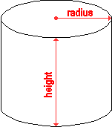 | Example:  $V=πr^{2}h$  $$V=π∙5^{2}∙10$$  $$V=π∙25∙10$$  $$V=π∙250$$  $$V=250π {cm}^{3}(exact)$$  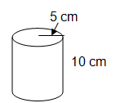  $V≈785 {cm}^{3} (estimate using π≈3.14)$
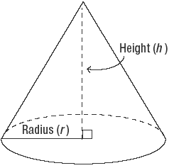  Cones:  $$V=\frac{1}{3}πr^{2}h$$ | Example:  $$V=\frac{1}{3}πr^{2}h$$  $$V=\frac{1}{3}πr^{2}h$$  $$V=\frac{1}{3}π∙16∙9$$  $$V=π∙\frac{1}{3}∙144$$  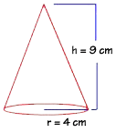  $V=π∙48$  $$V=48π {cm}^{3}(exact answer)$$  $$V≈150.72 {cm}^{3} (estimate using π≈3.14)$$
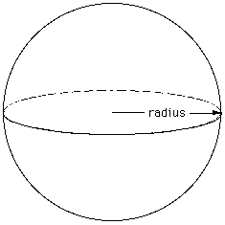  Spheres:  $$V=\frac{4}{3}πr^{3}$$ | Example:  $$V=\frac{4}{3}πr^{3}$$  $$V=\frac{4}{3}∙π∙4^{3}$$  $$V=\frac{4}{3}∙π∙216$$  $$V=π∙288$$  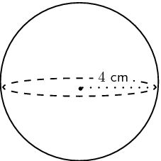  $V=288π {cm}^{3}(exact answer)$  $$V≈904.32 {cm}^{3}(estimate using π≈3.14)$$
Helpful Hints:

If you are given the DIAMETER instead of the radius, remember that 2r=d
(so divide the diameter by 2 to get the radius).

For the EXACT volume, leave π as part of your answer.
For an ESTIMATE or APPROXIMATION, use 3.14 as an estimate for π and multiply.

For estimated answers, a shortcut is to use $π≈3$
Just remember that your answer will be a little LOWER than the actual answer!

