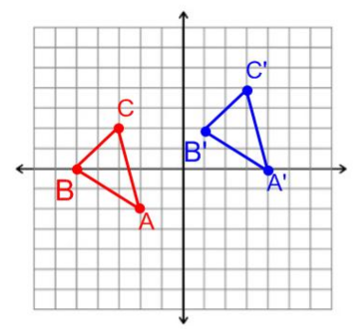
Transformations
Translations are slides. They can be horizontal (left or right) or vertical (up and down). If they are horizontal, they change the x coordinate. If they are vertical, they change the y coordinate. They lead to congruent figures (same size and same shape).
Example: If the point B (-5,0) were translated horizontally 6 units and vertically 2 unit, they rule would be (x,y)→(x+6, y+2), so the new point would be (1, 2)

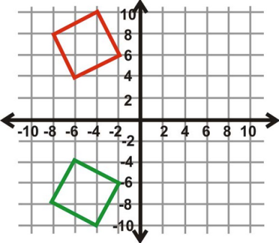
Reflections are flips that happen over a line of reflection. To reflect, you count the spaces from the point to the line of reflection. The reflected point would be the same number of spaces on the other side of the line. The rule for reflecting a figure over the x axis is that you keep the x value and change the sign of the y value. The opposite is true of reflecting over the y axis. You would keep the y value and change the sign of the x value. The figures would be congruent.
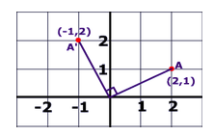
Example: If the figure at the right were reflected over the x axis, the red figure would become the green figure. The point (-6, 4) becomes (-6, -4). You keep the x and change signs of the y since you reflected over the x axis.
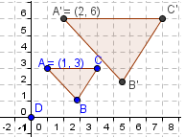
Rotations are turns around a center of rotation (a fixed point). They figure can turn clockwise or counterclockwise. The turn is measured in degrees. Typically, you either turn 90°, 180°, or 270°. The figures would be congruent. The picture at the right shows how to rotate a point (2,1) 90° counterclockwise.
Dilation means to either shrink or enlarge a figure. It is the only one that changes the size of the figure. If the size changes, a dilation has occurred and the figures are no longer congruent; they would be similar. The dilation involves a scale factor. If the scale factor is greater than one, the figure is enlarged. If it is less than one, the figure will shrink. The rule for a dilation is different. You would MULTIPLY the x and y value by the scale factor. To determine the scale factor from a picture, you can count the corresponding side lengths. Look at the figures to the right. Because the size changes, you know there was a dilation and the figures are similar. Side AC in the original figure is 3 units long. Side A’C’ in the dilated figure is 6 units long. Since 2X3 is 6, the scale factor is 2. (Remember, it is multiplied). This means the dilated figure is 2 times the size of the original figure. The coordinates for point A are (1,3). If you multiply both x and y by the scale factor, you get the new coordinates for A’ (2,6).
Summary of Transformations: Dilating a figure changes the size and therefore leads to similar figures. All other transformations lead to congruent figures.
Try these: Label each of the following as either similar or congruent:
_____________________ A dilation with a scale factor of ½ and a translation of 2 units horizontally.
_____________________ A reflection over the x axis and a rotation of 90° clockwise.
_____________________ (x,y)→(3x, 3y) Bonus: Can you describe the transformation?
Bonus: What is the scale factor?
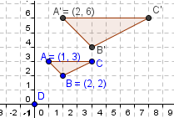
_____________________

Special Angles
When parallel lines are cut by a transversal, they create special angle relationships. Each relationship is either congruent (equal ) or supplementary (add up to 180°). You must know the relationships and if they are equal or supplementary. Study your vocabulary!
In the picture below, lines m and n are parallel and line p is a transversal.
Supplementary Angle Examples: | Congruent Angle Examples:
∠1 and ∠2 form a straight line and are supplementary  ∠1 and ∠7 are supplementary because they are same side exterior angles  ∠3 and ∠5 are supplementary because they are same side interior angles | ∠1 and ∠5 are congruent because they are corresponding angles  ∠3 and ∠6 are congruent because they are alternate interior angles  ∠2 and ∠7 are congruent because they are alternate exterior angles  ∠2 and ∠3 are congruent because they are vertical angles

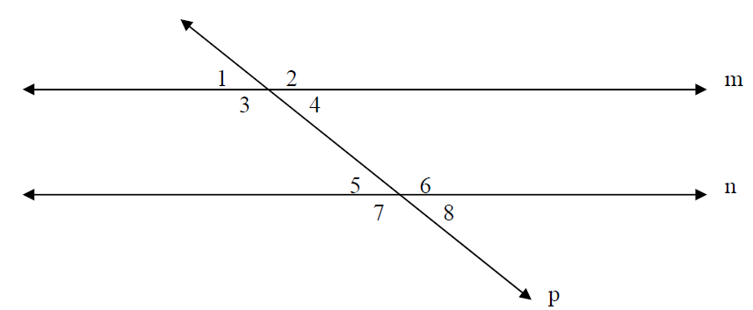
- What relationship exist between angles 1 and 2?  - Corresponding Angles  - Supplementary Angles  - Vertical Angles  - Alternate Exterior Angles | - What relationship exist between angles 2 and 3?  - Corresponding Angles  - Supplementary Angles  - Vertical Angles  - Alternate Exterior Angles
- What relationship exist between angles 1 and 5?  - Corresponding Angles  - Supplementary Angles  - Vertical Angles  - Alternate Exterior Angles | - What relationship exist between angles 2 and 7?  - Corresponding Angles  - Supplementary Angles  - Vertical Angles  - Alternate Exterior Angles
Triangles
- Any angles that form a straight line are supplementary and have a sum of 180°.
- The interior angles of a triangle have a sum of 180°.
- An exterior angle will be equal to the sum of its remote interior angles (the two furthest away).
All of these rules are true all of the time! You can use them to solve for missing angles.
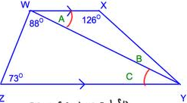 | 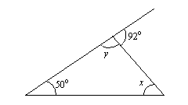 | 