Transformations | Transformation | Picture | Effect on Coordinates | Resulting Figures
 | Translations (slides) either horizontally or vertically (or both). | 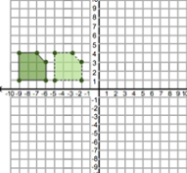 | Horizontal changes x value, if sliding left, decrease x. If sliding right, increase x. Vertical changes y value, if sliding up, y increases. If sliding down y decreases.  Example: A horizontal shift of 4 would change (x,y)→(x+4,y)  A vertical change of -4 would change (x,y) →(x,y-4) | Congruent
 | Reflection (flips) over a line of reflection (usually x or y axis) | 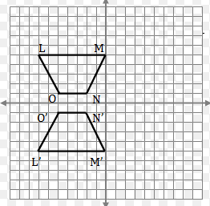 | If you reflect over the x axis, keep x value and change sign of y value. If you reflect over the y axis, keep y and change sign of x value.  Example: Reflect over x axis (x,y) → (x, -y)  Reflect over y axis (x,y) → (-x,y)
 | Rotations (spins) can be clockwise or counterclockwise | 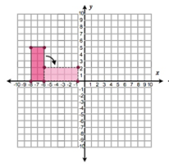 | To rotate a figure, you must have a number of degrees you would rotate. You must also have a direction, either clockwise or counterclockwise. Imagine spinning an object either 90, 180, 270, or 360 degrees. The rules are not as simple as the other transformations, so we will just focus on where the new image would be in the coordinate plane.
 | Dilations (enlarge or reduce) by a scale factor. | 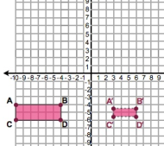 | MULTIPLY both x and y coordinates by the scale factor. Scale factor less than 1 means the shape is getting smaller. If scale factor is greater than one, the shape is enlarging.  Example: Scale factor of 2 (x,y) → (2x,2y) | Similar

