Solving Equations
In previous years, you learned to solve one and two step equations. Now, we want to add those with distributive property and variables on both sides (multi-step)
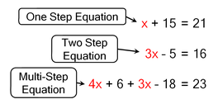
Steps to solving equations:
Step 1: Distribute (multiply through the parentheses).
Step 2: Combine like terms (on same side of the equation)
Step 3: Move all variables to one side (using inverse operations)
Step 4: Isolate the variable
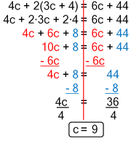
Distribute
Combine Like Terms
Variables on one side
Isolate variable

Solving equations means to find a solution. The solution is the value of the variable that makes the statement true. For example, if you are given x + 4 = 6, you know that x must be 2. 2 is the only value of x that makes the statement true. This is an example of an equation with one solution. Sometimes we have equations that have no solution. This means that there is not a value that will make the equation true. There are also equations that have infinitely many solutions. These equations are true for any and all values. The table below shows an example of each solution type.
One Solution | No Solution | Infinitely Many Solutions
Only one number makes the equation true.  Example: 2x = x + 1  -x -x  x = 1 | No number makes the equation true. Example: x + 1 = x + 2  -x -x  1$≠$ 2 (this is never true) | Any number makes the equation true.  Example: x + 0 = x  x = x (always true)

