Triangle Angle Facts 8.G.5
Skill Check  Stuck? Get a hint here!  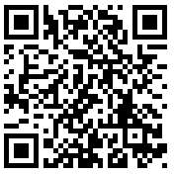  3 | Check your answers here!  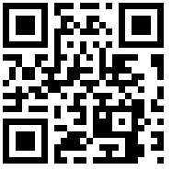
You Try!
- The angle measures of a triangle are 2x+5 degrees,  6x-5 degrees, and 7x degrees. What is the value of x?  - X = 10  - X = 12  - X = 15  - X = 29 | - The angle measures of a triangle are 2y+3 degrees, 9y-7 degrees, and 7y+4 degrees. Which of the following is NOT one of the angle measures of the triangle?  - 23° C. 83°  - 74° D. 97°
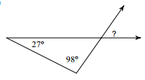  3. What is the measure of the missing angle?  A. 125° C. 25°  B. 55° D. 98° | 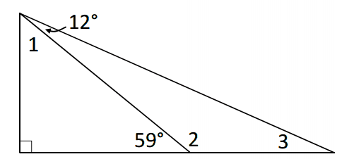  4. What is the measure of angle 3?  A. 121° C. 47°  B. 59° D. 71°

Triangle Angle Facts 8.G.5
Skill Check  Stuck? Get a hint here!  3 | Check your answers here!
You Try!
- The angle measures of a triangle are 2x+5 degrees,  6x-5 degrees, and 7x degrees. What is the value of x?  - X = 10  - X = 12  - X = 15  - X = 29 | - The angle measures of a triangle are 2y+3 degrees, 9y-7 degrees, and 7y+4 degrees. Which of the following is NOT one of the angle measures of the triangle?  - 23° C. 83°  - 74° D. 97°
3. What is the measure of the missing angle?  A. 125° C. 25°  B. 55° D. 98° | 4. What is the measure of angle 3?  A. 121° C. 47°  B. 59° D. 71°

