Transformations 8.g.1 a, b,&C, 8.G.2, 8.G.3, 8.G.4
Skill Check  Stuck? Get a hint here!  1 |  | Check your answers here!
You Try!
- Which of these describes the transformation of the triangle?  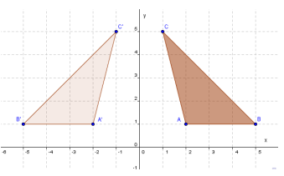  - Reflection over the x-axis  - Reflection over the y-axis  - Rotation 90° clockwise about the origin  - Rotation 180° clockwise about the origin | - Triangle JKL has vertices J(2,4), K(3,1), and L(3,3). A translation maps the point J to J’(3,3). What are the coordinates of K’?  - (-3,1)  - (2,2)  - (3,2)  - (4,0)
- A figure is located ENTIRELY in the third quadrant. If it is reflected over the y-axis, in which quadrant will the reflected image lie?
- Quadrant I
- Quadrant II
- Quadrant III
- Quadrant IV
- Which transformation will result in an image that is similar, but not congruent, to the pre-image?
- Translation B. Reflection C. Rotation D. Dilation

Transformations 8.g.1 a, b,&C, 8.G.2, 8.G.3, 8.G.4
Skill Check  Stuck? Get a hint here!  1 |  | Check your answers here!
You Try!
- Which of these describes the transformation of the triangle?  - Reflection over the x-axis  - Reflection over the y-axis  - Rotation 90° clockwise about the origin  - Rotation 180° clockwise about the origin | - Triangle JKL has vertices J(2,4), K(3,1), and L(3,3). A translation maps the point J to J’(3,3). What are the coordinates of K’?  - (-3,1)  - (2,2)  - (3,2)  - (4,0)
- A figure is located ENTIRELY in the third quadrant. If it is reflected over the y-axis, in which quadrant will the reflected image lie?
- Quadrant I
- Quadrant II
- Quadrant III
- Quadrant IV
- Which transformation will result in an image that is similar, but not congruent, to the pre-image?
- Translation B. Reflection C. Rotation D. Dilation

