Relations are sets of ordered pairs. They can be shown in a variety of ways. Some relations are also functions. Functions are a special type of relation. To be a function, there can only be one output assigned to each input.
Functions | Non functions
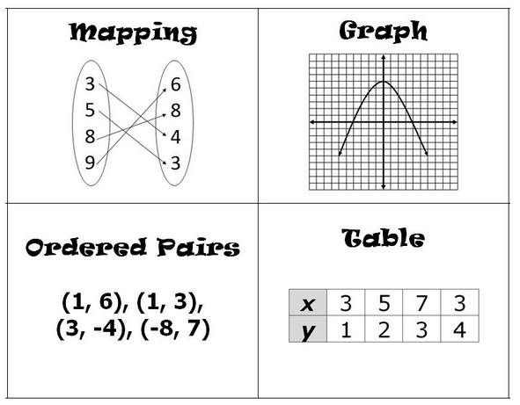  (1,3), (2,3), (3,3) | 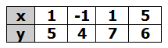  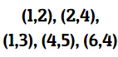  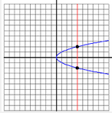  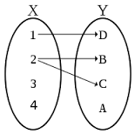

How can you tell if a relation is a function?
Ordered Pairs: If x doesn’t repeat, it is a function.
Mappings: If each x value has its own y value, it is a function.
Graph: X can’t have more than one y value, so if two points are “stacked” then they share an x value and therefore not a function.
Table: If x values don’t repeat, it is a function.
*Remember, negatives and positives indicated two different values and are not the same number. So, if you have (-1,9) and (1,9), you still have a function.

