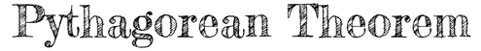
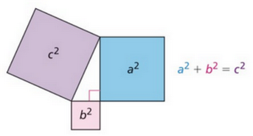 |  | 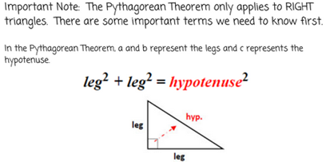
The Pythagorean Theorem for right triangles is $a^{2}+b^{2}=c^{2}$, where a and b are legs and c is the hypotenuse. It can be used to find missing side lengths of right triangles, and it can be used to find the distance between two points on the coordinate plane.
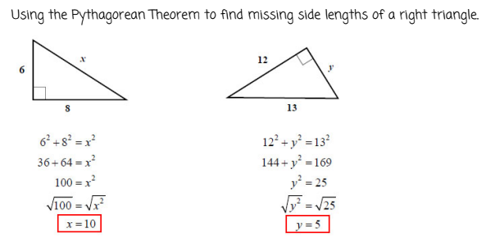
Take the square root at the end if you’re finding a missing length!
Remember if you’re given a leg and the hypotenuse, you’ll need to SUBTRACT to get to the other leg length!

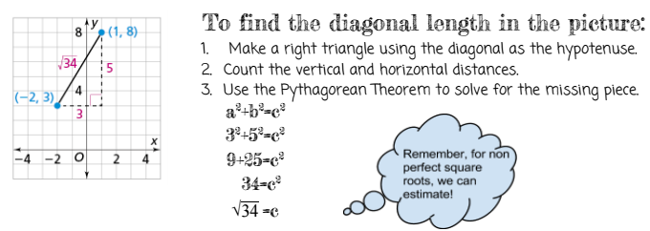
Converse of the Pythagorean Theorem:
For any three side lengths (a, b, and c) if $a^{2}+b^{2}=c^{2}$ then the three lengths form a right triangle. Remember that the hypotenuse always goes in for c, so c should be the longest length.
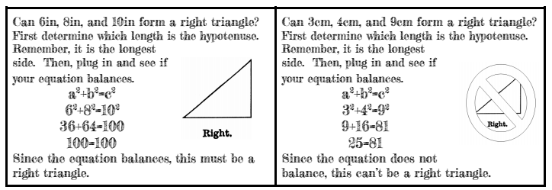
pythagorean theorem in 3-d
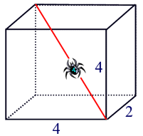 | In the 3-dimensional figure to the left, we can use a variation on the Pythagorean Theorem to find the length of the diagonal that the spider is on.  3-D Pythagorean Formula: $l^{2}+w^{2}+h^{2}=d^{2}$ (d is the length of the diagonal)  $$4^{2}+2^{2}+4^{2}=d^{2}$$  $$16+4+16=d^{2}$$  $$36=d^{2}$$  $$\sqrt{36}=d=6$$
