Name: __________________________________________________ Date: ____________________ Class: _______
Practice with Scientific Notation
Section 1: Converting from Standard Form to Scientific Notation
- 456, 000,000,000 __________________________ 2. 0.0000000000456 __________________________
3. 5,900,000,000,000 __________________________ 4. 0.000000672 ______________________________
5. The distance that light travels in one year 5,900,000,000,000 miles ________________________________
6. The mass of the earth 6,020,000,000,000,000,000,000,000kg ____________________________________
7. The wavelength of one type of x ray 0.000000000128m _________________________________________
8. The mass of an electron 0.000000000000000000000000091g ____________________________________
Section 2: Converting from Scientific Notation to Standard Form
9. 4.475 x 10⁵ ______________________________ 10. 1.352 x 10⁻⁵__________________________________
11. 9.1 x 10¹⁰ ______________________________ 12. 2.3 x 10⁻³ ____________________________________
Section 3: Multiplying and Dividing with Scientific Notation
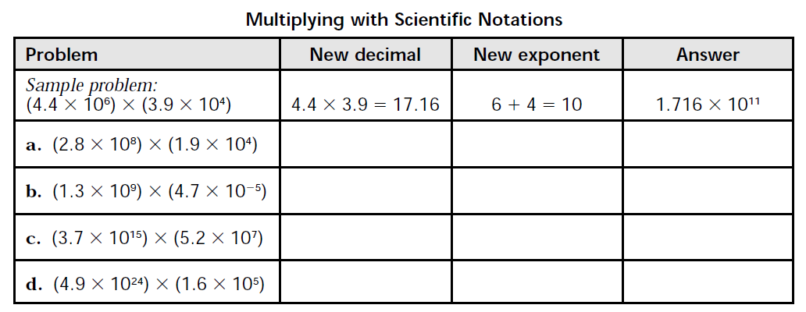
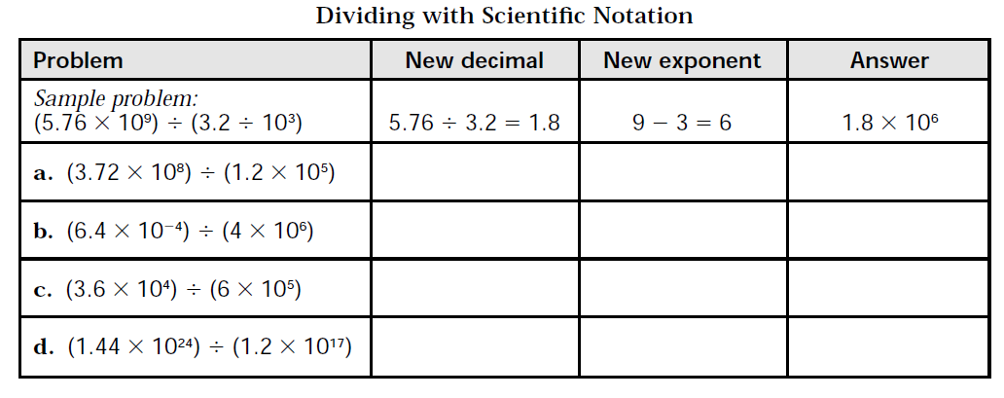
Section 4: Word Problems with Scientific Notation
The mass of one hydrogen atom is 1.67 x 10⁻²⁷ kg. A cylinder contains 3.01 x 10²³ hydrogen atoms. What is the total mass of the hydrogen?

The average distance from Earth to the sun is 1.5 x 10¹¹ m. The speed of light is 3 x 10⁸ m/s. Approximately how long does it take for light to travel from the sun to Earth?

Section 5: Comparing numbers in Scientific Notation
The half-life of uranium-238 is 4.5 x 10⁹ years. The half-life of uranium-234 is 2.5 x 10⁵ years. How many times greater is the half-life of uranium-238 than that of uranium-234?

The state of Colorado covers about 1.04 x 10⁵ square miles. The Indian Ocean covers about 2.808 x 10⁷ square miles. How many times bigger than Colorado is the Indian Ocean?

