

Transversal

Special Angle Relationships

In addition to the “triangle rules” there are some special angles created when parallel lines are cut by a transversal. Let’s review these.

|  |  |
| --- | --- |
| **Parallel Lines-lines that never intersect** | **Transversal-a line that intersects two or more lines.** |
|  |  |

Put them together and you create some special angles.

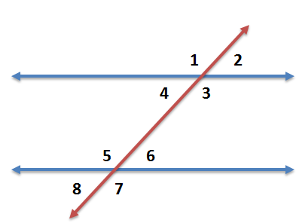

|  |  |  |
| --- | --- | --- |
| Relationship | Definition | Examples |
| Alternate Interior Angles  (Equal) | Angles that are on opposite sides of the transversal and on the inside of the parallel lines | ∠4 and ∠6  ∠3 and ∠5 |
| Alternate Exterior Angles  (Equal) | Angles that are on opposite sides of the transversal and on the outside of the parallel lines | ∠1 and ∠7  ∠2 and ∠8 |
| Same Side Interior Angles  (Sum of 180°) | Angles that are on the same side of the transversal and inside the parallel lines | ∠4 and ∠5  ∠3 and ∠6 |
| Same Side Exterior Angles  (Sum of 180°) | Angles that are on the same side of the transversal and on the outside of the parallel lines | ∠1 and ∠8  ∠2 and ∠7 |
| Vertical Angles  (Equal) | Angles that are opposite each other at an intersection | ∠1 and ∠3, ∠2 and ∠4  ∠5 and ∠7, ∠6 and ∠8 |
| Corresponding Angles  (Equal) | An interior and exterior angle pair that are on the same side of the transversal but not adjacent | ∠1 and ∠5, ∠4 and ∠8  ∠2 and ∠6, ∠3 and ∠7 |

*Two others to recall: Complementary Angles are angles that have a sum of 90° and Supplementary Angles have a sum of 180°