Name: __________________________________________ Date: _______________ Period: _________
Investigating Translations
A transformation is the change in the size or position of a figure. A translation is a transformation in which each point of a figure moves the same distance and in the same direction.
- Translate ∆ABC to become ∆A’B’C’ using the steps below.
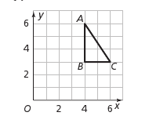
- From A, count down 2 units and to the left 3 units. Label the new point A’ (A-prime).
- Find and label points B’ and C’ by counting down 2 units and left 3 units.
- Draw ∆A’B’C’.

- Compare the lengths of the three line segments. What do you notice about each of these segments?

Segment AB _______ Segment A’B’ _______

Segment BC _______ Segment B’C’ _______

Segment AC _______ Segment A’C’ _______

- What does this tell you about the effect that translations have on side lengths?

- Using the definition of translation above, explain why ∆A’B’C’ is a translation of ∆ABC.

- Using a protractor, measure the angles of ∆ABC and ∆A’B’C’.

m$∠$ A _____ m$∠$ A’______ m$∠$ B ______ m$∠$ B’ ______ m$∠$ C ______ m$∠$ C’ ______

- Compare $∠$A to $∠$A’, $∠$B to $∠$B’ and $∠$C to $∠$C’. What do you notice about each angle pair?

- What does this tell you about the effect that translations have on angles?

- When translating a figure, what can you summarize about each of the following?

The corresponding angles ___________________________

The corresponding side lengths_______________________

- Look at the triangle shown on the coordinate plane.
- List the ordered pairs for the vertices of triangle ABC.
A ___________
B ___________
C ___________
- Translate triangle ABC by shifting each of the vertices -6 units vertically. Draw the new triangle and label the vertices A’, B’, and C’. List the ordered pairs for the vertices of triangle A’B’C’.
A’ ___________ B’ ___________ C’ ___________

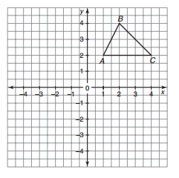
Pay close attention to the intervals
- What do you notice about the ordered pairs after you translated vertically? Did both coordinates change?
By how much?

- Translate triangle ABC -6 units horizontally instead. Draw the new triangle and label the vertices A’’, B’’, and C’’. List the ordered pairs for the vertices of triangle A’’B’’C’’.

A’’ ___________ B’’ ___________ C’’ ___________

- What do you notice about the ordered pairs after you translated horizontally? Did both coordinates change? By how much?

- IF you were to translate triangle ABC 10 units vertically to form triangle DEF, what would be the ordered pairs of the corresponding vertices? (Hint: You shouldn’t NEED the graph to answer this question)

D ___________ E ___________ F ___________

- IF you were to translate triangle ABC 10 units horizontally to form triangle DEF, what would be the ordered pairs of the corresponding vertices? (Hint: You shouldn’t NEED the graph to answer this question)

D ___________ E ___________ F ___________

