Name: __________________________________________ Date: _______________ Period: _________
Investigating Rotations
A rotation is a transformation that turns a figure around a fixed point called the center of rotation. A rotation is clockwise if its direction is the same as that of a clock hand. A rotation in the other direction is called counterclockwise. A complete rotation is 360°.
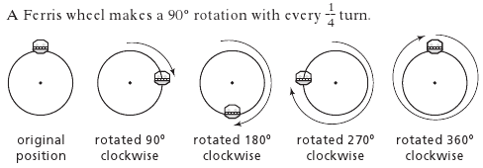
- Plot the following points on the coordinate plane. Then, rotate each point 90° clockwise about the origin. Label the new points A’, B’, and C’. | 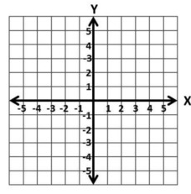
A (1,1)
B (1,3)
C (3,1)

The rotation of figure KLMO 180° about (0,0) is shown. In K’L’M’O, point K’ is the rotation of point K, point L’ is the rotation of point L, and point M’ is the rotation of point M.
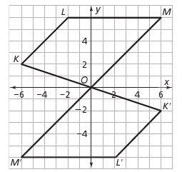
2. Using a ruler, compare the lengths of segment OM and segment OM’. What do you notice?

3. What other pairs of side lengths can you find that have the same length?

4. When a point is rotated, how does its distance from the center of rotation change?

5. Describe the movement of the point at the center of rotation. What happens to point O when the figure is rotated?

6. When you rotate a figure 180°, does it matter whether you rotate it clockwise or counterclockwise? Explain.

7. List the coordinates of the vertices of polygon KLMO and K’L’M’O’. What do you notice about the vertices of a polygon that is rotated 180°?
K ___________ K’ ___________
L ____________ L’ ____________
M ___________ M’ ____________
O ___________ 0’ _____________

- Measure each corresponding angle. What do you notice about the angle pairs?

m ∠K ___________ m ∠K’ ___________
m ∠L ____________ m ∠ L’ ____________
m ∠M ___________ m ∠M’ ____________
m ∠O ___________ m ∠0’ _____________

- When rotating a figure, what can you summarize about each of the following?

The corresponding angles ___________________________

The corresponding side lengths_______________________

