Name: _________________________________________ Date: ____________________ Period: ____
Investigating Reflections
A reflection is a transformation that flips an image over a line called the line of reflection. Images shown in mirrors are reflections.
- The reflection of two points across the line y=3 is shown. Point G’ is the reflection of point G. Point H’ is the reflection of point H.
- What is the shortest distance from G to the line of reflection?

- Compare your answer to the distance from G’ to the line of reflection.

- Does this comparison hold true for H and H’ ?

- Using this information, write a general rule for reflecting a point across a line.

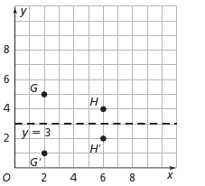

- Using this information, write a general rule for reflecting a point across a line.

- The reflection of a triangle across the line x=4 is shown below.
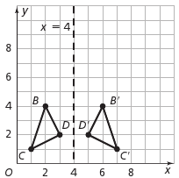
- Imagine folding the graph over the line x=4. What would happen?

- Measure the distance from each of the following.

B and the line of reflection ___________
B’ and the line of reflection ___________
C and the line of reflection ___________
C’ and the line of reflection ___________
D and the line of reflection ___________
D’ and the line of reflection ___________
- Using a ruler, measure the corresponding sides of triangle BCD and B’C’D’. What do you notice about the lengths of the corresponding sides of the triangles?

- Using an angle ruler, measure the corresponding angles. What do you notice?

- Write a rule for the reflection of a polygon across a line.

- When reflecting a figure, what can you summarize about each of the following?

The corresponding angles ___________________________

The corresponding side lengths_______________________

- Reflect parallelogram ABCD, using the y axis as the reflection line, to form parallelogram A’B’C’D’.
Pay attention to the intervals!

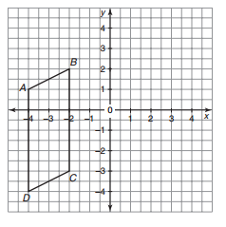
- List the ordered pairs for the vertices of parallelogram ABCD and parallelogram A’B’C’D’.
A ________ A’ ________
B ________ B’ ________
C ________ C’ ________
D ________ D’ ________

- What do you notice about the ordered pairs of the vertices of the original image and its reflected image over the y-axis?

- A traingle has vertices at A(-4,3), B(1,5), C(2,-2).

- If this triangle is reflected over the x-axis, what would the ordered pairs of the reflection’s vertices be?

- If this triangle is reflected over the y-axis, what would the ordered pairs of the reflection’s vertices be?

