Name: __________________________________________ Date: _______________ Period: _________
Investigating Dilations
A dilation is a transformation of a figure that changes its size but not its shape. The scale factor of a dilation determines the extent of the change in size. A dilation is an enlargement when the scale factor is greater than 1. It is a reduction when the scale factor is less than 1. When you dilate a figure, you shrink or enlarge a figure from the center of dilation.
The graph shows a dilation of ∆ AOB to ∆ A’OB’ with the center of dilation at the origin.
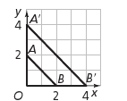
- Is ∆ A’OB’ an enlargement or a reduction of ∆ AOB?

- How many times greater is OA’ than OA?

- How many times greater is OB’ than OB?

- How many times greater is A’B’ than AB?

- What is the scale factor?

- When examining a dilation, what is the least information you need in order to determine the scale factor?

- What happened at the center of the dilation (Point 0) in this transformation of ∆ AOB?

- Using the grid below, draw ∆LOM with vertices L(0,4), O (0,0), and M(2,0). Then draw ∆L’OM’ as a dilation of ∆LOM with the center of dilation at (0,0) and a scale factor of 1.5.

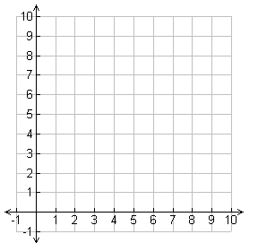
- After measuring the corresponding angles, what can you conclude about the angles of a dilated figure?

- When dilating a figure, what can you summarize about each of the following?

The corresponding angles ___________________________

The corresponding side lengths_______________________

- A triangle has vertices at A(-2, 14), B(-6,6), and C(-14,6). If it were dilated using the origin as the center of dilation and a scale factor of ½, what would be the coordinates of the dilated triangle A’B’C’?

PUTTING IT ALL TOGETHER:
Congruent figures are those that have the same size and shape. Similar figures are those that have the same shape but not necessarily the same size.

There are _____________________ types of transformations. They are ___________________________, ______________________________, _____________________________, and _____________________. _______________________________, _______________________, and _________________________ will result in ________________________ figures. ____________________________ will result in _______________________ figures.

