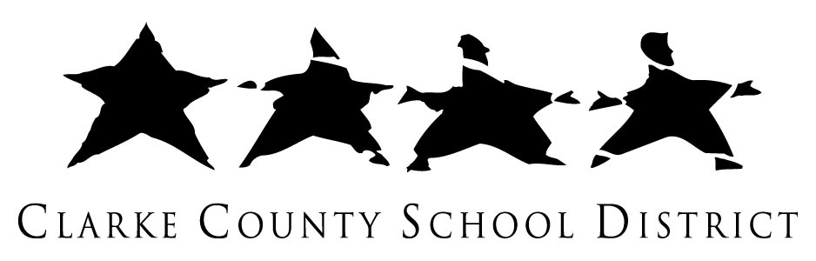
Burney-Harris-Lyons Middle School
Course Syllabus
Course Title: 8th Grade Math
Teacher Information:
Ms. Maggie Hendricks
(706) 548 – 7208
hendricksm@clarke.k12.ga.us
Website: www.bhlmath8.weebly.com
Course Description: Eighth grade students use Connected Mathematics and other resources to explore topics in algebra and geometry. Through these explorations and discussions afterward, students develop their understanding of the concepts to help them excel on state directed assessments and throughout future math courses. Our goal is for students to learn problem solving skills that will carry them through life.
Materials: Each student is required to bring the following items to class everyday: a math binder, loose leaf paper, graph paper, pencils, scissors, and a glue stick.
Grading: Grades are based on the student’s performance in each of the categories below.
Formative Assessment (30%)
Summative Assessment (60%)
Daily Work (10%)
Formative Assessment: Examples include but are not limited to----Check-ups, Quizzes, and Classroom Activities
Summative Assessment: Examples include but are not limited to----Major Tests, Performance Tasks, and Projects
Homework: There will be homework given periodically to assess student progress and reinforce classroom learning. Homework assignments will be posted and students are responsible for recording the assignments. It is very important that students complete all homework assignments on time. Late homework will only be accepted in the case of an absence.
Make-Up Policy: Students are required to make up class work missed during any school absences. It is the student’s individual responsibility to see teachers, obtain the missed assignments, and turn in makeup work. Please review the district policy regarding make-up work.
Expectations: The mission of Burney-Harris-Lyons Middle School is to nurture successful lifelong learners through high expectations and mutual respect. Students are expected to follow the classroom policies and procedures. Most importantly, students are expected to work hard and try their best on everything they do in class.
I look forward to a wonderful year! If you have any questions or concerns please contact me.

Maggie Hendricks

